[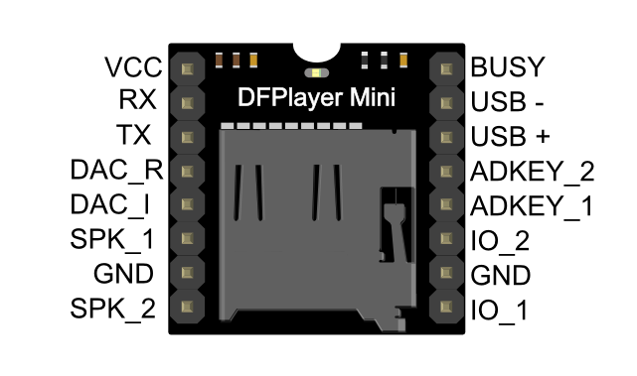](https://www.dfrobot.com/wiki/images/a/ab/Miniplayer_pin_map.png)

[](https://www.dfrobot.com/wiki/images/a/ab/Miniplayer_pin_map.png)